**Bulletin announcements (4) for medical debt ministry 2024**

**For Sunday, September 29, 2024**

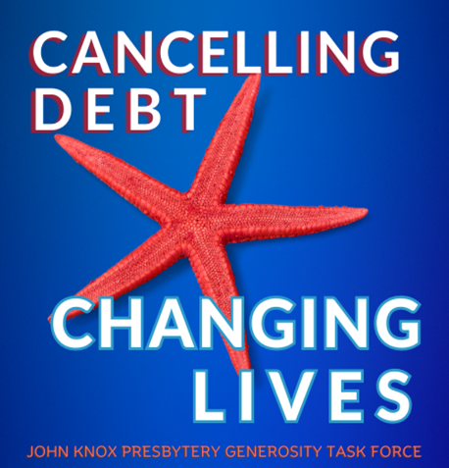

John Knox Presbytery is once again raising money to cancel medical debt. Our ministry is called the Starfish Campaign. Too many families suffer great hardship trying to pay their medical bills. Unfortunately, medical debt can turn a family’s life upside down. Every dollar contributed to the Starfish Campaign will cancel at least $100 of medical debt. Donate online at jknox.org or through our Sunday offering. Please make your check out to our church and mark it “The Starfish Campaign”. Together, we make a big difference!

**For Sunday, October 6, 2024**

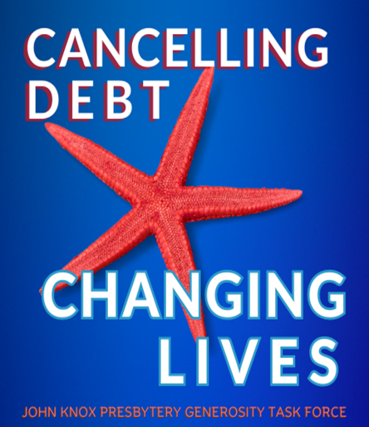

John Knox Presbytery is partnering with an organization called Undue Medical Debt on October 20 to purchase and cancel medical debt on a grand scale. Because Undue Medical Debt is good at what they do, every dollar the Presbytery raises will remove at least $100 of medical debt for a family. That really makes a difference in people’s lives! There are two ways to contribute to this ministry. Give online at jknox.org. You can also contribute through our Sunday offering. Please make your check out to our church and mark it “The Starfish Campaign”. Others can live because we give!

**For Sunday, October 13, 2024**

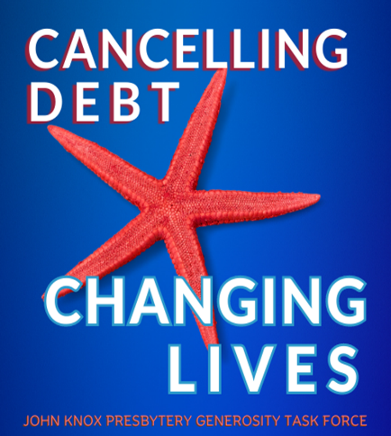

John Knox Presbytery is again participating in a ministry to remove the burden of medical debt for families. Churches in our Presbytery, all 55 of them, have been invited to contribute to this ministry. In only two years, contributions Presbytery-wide have been able to cancel $5,832,268.74 of medical debt for 4,761 families. What a huge impact we’re making! Contributions can be made online at jknox.org or through our regular Sunday offering. Make your check out to our church and mark it “The Starfish Campaign”. Together, we can unleash the power of hope!

**For Sunday, October 20, 2024**

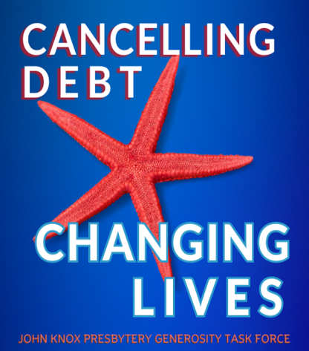

John Knox Presbytery’s ministry to purchase and cancel medical debt comes to a close today. It’s estimated that every day, one of two Americans with medical debt is forced to choose between paying medical bills and covering basic needs. Due to the expertise of the Presbytery’s mission partner, Undue Medical Debt, every dollar you contribute goes on to wipe out at least $100 of debt for the families we are helping.

There is still time to contribute through our regular offering this morning. Please make your check out to our church and mark it “The Starfish Campaign”. Thank you for your generosity. God accepts what we offer and makes it amazing!

**Minute for Mission—September 29, 2024**

John Knox Presbytery’s ministry to cancel medical debt is called “The Starfish Campaign”. Here’s why. As the story goes, a man was walking along the beach. From a short distance, he saw a young boy pick something up and toss it into the water. When the man was able to catch up, he saw what the boy was doing…picking up starfish and throwing them back into the ocean. The boy explained that, if the starfish remained on the beach they would die.

The man tried to reason with the boy and told him, “There must be thousands of starfish on this beach. You can’t save them all. What difference can you make?” The boy had found another starfish. As he picked it up and nimbly sent it into life-giving water, he smiled and told the man, “I made a difference to that one!”

Beside adverse health effects like high blood pressure, stress and poor nutrition,

those struggling with medical debt can face bankruptcy and homelessness. Many are less likely to seek medical care for preventative services or treatment. There is over 200 billion dollars of medical debt in the United States. That’s a huge number. We won’t be able to help everyone. But…there is hope! On October 20, our entire Presbytery has been invited to raise money to eliminate medical debt. Every dollar raised will be sent to an organization called Undue Medical Debt, a leader in the purchase and removal of medical debt. They are able to buy large bundles of debt that have gone to a collection agency for pennies on the dollar. Their understanding of the medical debt industry allows what we contribute to go much further. Five dollars will remove at least $500 of medical debt for someone struggling to pay their bills.

This is an important ministry and we want to be a part of it. We ask you to be generous because God will grow our dollars many times over. The need is great. Because God accepts what we offer and makes it amazing, our congregation can make a difference and bring hope to many people.

**Minute for Mission—October 6, 2024**

In 2019, the Presbyterian Church (USA) introduced a new program called “The Matthew 25 Initiative”. The reference is to Matthew 25:31-46 when Christ comes to reward those who fed the hungry, offered a drink to the thirsty, visited those who were sick or in prison, clothed the naked and welcomed strangers. Jesus adds, “Just as you did it to one of the least of these, who are members of my family, you did it to me.”

John Knox Presbytery has already joined the Matthew 25 initiative. One area Matthew 25 targets is “the eradication of systemic poverty”. All of the churches in our Presbytery have been invited to participate in a ministry to remove the burden of medical debt for as many people as possible. (**Last year, our congregation contributed $____ and made a difference to many families**.) We can free families from the prison of medical debt. Working with a ministry partner, an organization called Undue Medical Debt, each dollar the Presbytery receives will remove at least $100 of medical debt for a family. The culmination of this fundraising effort will take place on October 20. Gifts can be made anytime between now and October 20 by placing them in the offering plates. Checks should be made out to our church. Please mark your offering “The Starfish Campaign”. Gifts can also be made online on the Presbytery’s website, jknox.org. Together, and with God’s help, we are going to change peoples’ lives!

**Minute for Mission—October 13, 2024**

Christians are called to live lives of gratitude. As we give thanks for all that God has given us, the same spirit of thankfulness encourages us to help others. Churches in John Knox Presbytery are again participating in a ministry to purchase and eliminate medical debt. The target date is October 20. Our congregation wants to share in this ministry so we’re raising money to help as many families as we can escape the burden of medical debt. Those who struggle with this type of debt can have their credit rating destroyed. Many suffer the physical effects of stress and worry. Some families have even become homeless trying to pay their medical bills. Almost half of those carrying medical debt don’t think they’ll ever be able to pay it off.

Our donations and those of other churches in John Knox Presbytery will be sent to an organization called Undue Medical Debt, a leader in the area of medical debt removal. In just two years, the Presbytery has sent $47,000 to Undue Medical Debt where it has been able to wipe out over $5.8 million of debt for 4,761 families. That’s a lot of bang for the buck! Those whose debts have been significantly reduced or cancelled altogether receive a yellow envelope containing that good news. As you can imagine, those folks experience many emotions when they open the envelope to discover what has happened…relief, joy and gratitude. Here’s what one woman from Ohio said in a thank-you note to Undue Medical Debt: “Thank you, Undue Medical Debt, for this completely unexpected help! I was diagnosed with, operated on and treated for breast cancer in 2021. The fear was overwhelming. I have no idea how you were made aware of this debt, but I am immensely grateful to good people who help others with no ulterior motives! I pray you will be blessed for such generous kindness .” Your contribution may be placed in the offering plates through next Sunday. Please make your check out to our church and mark it “The Starfish Campaign”. You may also donate online by going to the Presbytery’s website, jknox.org. Let’s help send out a lot more of those yellow envelopes and give hope to as many families as we can!

**Minute for Mission—October 20, 2024**

Morgan Freeman’s character in “The Shawshank Redemption” may have said it best: “Fear can hold you prisoner. Hope can set you free.” For many Americans drowning in medical debt, hope is only a memory. The trouble is the medical debt they’re carrying. Medical bills leave too many Americans overwhelmed and devastated. Their recovery from debt is often deferred…and it’s rarely a choice. Getting sick or being involved in an accident can start a family down the road to homelessness, bankruptcy and a loss of hope. Our congregation is joining other churches in John Knox Presbytery in a ministry of hope. We’re raising money to remove medical debt for as many people as possible. We can be what the prophet Isaiah called “repairers of the breach” and bring hope to struggling families.

Every dollar received will remove at least $100 in medical debt. To give you an idea what our ministry means to those we help, listen to words of gratitude from Alan in Iowa: “There are times when medical necessity results in debts that are terribly difficult to manage, no matter how hard you try. Undue Medical Debt's generous act of debt abolishment has allowed me to breathe a sigh of relief. Thank you.”

Offerings can be placed in the plates this morning. Please make your check out to our church and mark it “The Starfish Campaign”. That name reminds us we are unable to help every family who bears the burden of medical debt…but we can help many and make a huge difference in their lives. By participating in this ministry, we will be helping families reestablish a better credit score and give them a chance to get a new start. Together, we can unleash the power of hope!

**(Use this newsletter article if your congregation has not**

**yet donated to the Starfish Campaign.)**

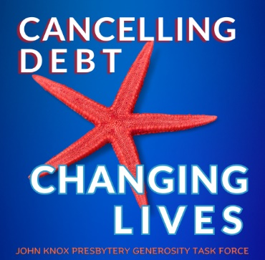

**A Ministry of Hope**

Whether as individuals or as a community of faith, we are called to serve those in need…not only to notice their need but also to do something about it. Our congregation is going to have the opportunity to help those who are suffering under the weight of medical debt through donations to the Starfish Campaign.

Medical debt is all too easy to accumulate. All it takes is getting sick or being involved in an accident. The burden of medical debt turns people’s lives upside down. Home foreclosures and bankruptcies are common. A tarnished credit rating makes it next to impossible to take out a loan or rent an apartment. In too many cases, trying to pay a medical bill can deplete a person’s savings. Some have even become homeless. Even worse, a lot of people carrying medical debt do not pursue the care they need or buy medications that will keep them healthy.

October 20 is the culmination of the Starfish Campaign. Every dollar received will be sent to an organization called “Undue Medical Debt”. They are able to buy large bundles of medical debt for pennies on the dollar. They then use the money we donate to eliminate as much medical debt as possible. Every dollar they receive will be able to wipe out at least $100 of medical debt for someone. Talk about bang for your buck!

Donating to this ministry is easy. You may contribute through your regular Sunday offering by placing your gift in the plate during worship. Please make your check out to our church and mark it “The Starfish Campaign”. There is also an online giving option on the Presbytery’s website, jknox.org. Together, we can impact a lot of families! With their debts forgiven and their credit rating improved, it's absolutely good news to the families we’re helping. Truly God accepts what we offer and makes it amazing!

**(Use this newsletter article if your congregation has**

**donated to the Starfish Campaign in the past.)**

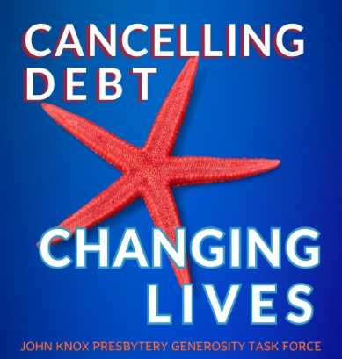

**Removing Medical Debt in 2024**

Once again in 2024, (YOUR CHURCH NAME) will raise money to support a Presbytery-wide ministry to cancel medical debt. John Knox Presbytery’s mission partner, Undie Medical Debt (formerly RIP Medical Debt), is able to buy large bundles of medical debt from collection agencies and hospitals for pennies on the dollar. This allows every dollar we contribute to do the work of at least $100 and greatly increase the impact of our ministry!

It’s called The Starfish Campaign because we know we cannot help every family carrying medical debt. But we can still help many people. In only wo years, this ministry has cancelled medical debt for close to 5,000 families. To the families we are able to help, our ministry means the world. A recent letter received by Undue Medical Debt tells the story. A woman from North Carolina shared, “This debt has been a source of stress for years. I disputed it because I had health insurance but was told it hadn’t gone into effect in time for my pregnancy appointments. When I received my letter stating the debt was paid with help from a church, I was brought to tears. I feel like God sent me a blessing. Thank you so much!”

Families struggle under the weight of medical debt for years. It’s a constant source of anxiety and stress as they try unsuccessfully to balance providing basic needs and paying their debt. When that debt is removed, everything changes. Lives are turned around. Hope is restored where no hope preciously existed. Tears of joy flow freely. This is what our participation in the Starfish Campaign accomplishes.

Please give generously. Even a small gift will have a huge impact. Ten dollars will cancel $1,000. This year’s fundraising efforts will culminate on Sunday, October 20 but donations can be made at any time. Simply mark your gift “The Starfish Campaign”.

**(This is a newsletter article that can be used after the Presbytery**

**announces the total received, how much medical debt was**

**removed and how many families were helped)**

**Removing medical debt…✓**

“*Now to him, who by the power at work within us is able to accomplish abundantly far more than all we can ask or imagine, to him be glory in the church and in Christ Jesus to all generations, forever and ever. Amen.”* --Ephesians 3:20-21

On October 20, all the churches in John Knox Presbytery were invited to participate in a ministry to remove the burden of medical debt for as many people as possible. The totals are now in and, altogether, $________ was raised. Our congregation generously contributed $__________. The entire amount was sent to Undue Medical Debt, a nonprofit organization whose mission is to buy medical debt from collection agencies for pennies on the dollar and cancel it.

Ready for the total amount of debt our ministry purchased and forgave? $_______! That is astonishing! The lives of _____ people and their families have indeed been blessed by the ministry God has called us to. The quote above is from the apostle Paul’s letter to the church at Ephesus. It was written close to 2,000 years ago but the words still ring true. God is able to accomplish a great deal more than we can imagine, even in our wildest dreams. Thank you, church, for this miracle that God has performed in our midst. It’s proof positive that God accepts what we offer and makes it amazing!

**(This is a sample press release, inviting your church’s community to contribute)**

Press release (Month, Day, Year) (your town) **CAMPAIGN TO REMOVE MEDICAL DEBT**

For immediate release

Church name and logo

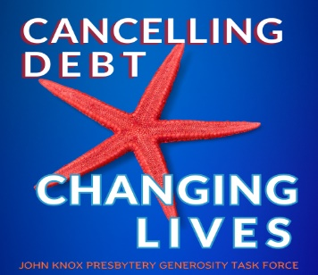

A major survey suggests people in the United States owe more than $200 billion in medical debt. Those struggling to pay their medical debt often suffer adverse health effects such as high blood pressure, anxiety and poor nutrition. They can also face bankruptcy and homelessness. Many are less likely to seek medical care for preventative services or treatment. Removing the burden of medical debt changes people’s lives and gives them renewed hope. Their credit rating improves. They are able to rent an apartment or apply for a loan. And, as they receive a second chance, their mental and physical health improve.

(Your church) of (your community) is participating in a fundraiser with a nonprofit organization that purchases medical debt and cancels it. In the last two years alone, working with an organization called Undue Medical Debt, the congregations in John Knox Presbytery have raised over $47,000 and retired just over $5.8 million dollars in medical debt for 4,761 families. Members of the (Your church) congregation were so impressed, they are raising money again and inviting others in the community to join them. (your church) is committed to helping families struggling under the weight of medical debt by providing hope for the future. They are excited to be able to raise money to buy medical debt for just pennies on the dollar and make it disappear. (Name of local church official) calls it, "Tremendous bang for the buck."

(your church)’s efforts are targeted to conclude October 20. Contributions from the (your city) community may be sent at any time to (your church name and mailing address). Donors are asked to mark their contribution “The Starfish Campaign”.

More information on Undue Medical Debt can be found at https://unduemedicaldebt.org. Their guarantee is that, for every $1 donated, at least $100 in medical debt will be forgiven.

Media contact:

Name

Email address

Contact phone number

Website address:

