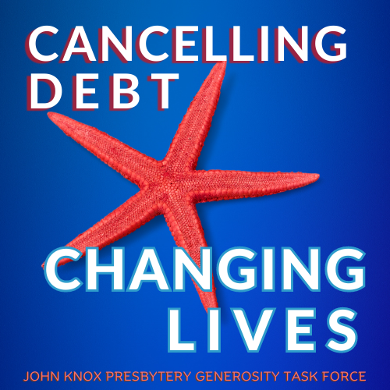

The

Starfish

Campaign

The Generosity Task Force chose the starfish logo to remind us that every fundraising effort is valuable. We undertake ministry even if we cannot help everyone, which is almost always the case anyway. The ministry we do changes people’s lives. It mans the world to every family we help.

It’s a familiar story. A man was walking along the beach. From a short distance, he saw a young boy pick something up and toss it into the water. When the man was able to catch up, he saw what the boy was doing…picking up starfish and throwing them back into the ocean. The boy explained that, if the starfish remained on the beach they would die.

The man tried to reason with the boy and told him, “There must be thousands of starfish on this beach. You can’t save them all. What difference can you make?” The boy had found another starfish. As he picked it up and nimbly sent it into life-giving water, He smiled and told the man, “I made a difference to that one!”

With medical debt in the United States at more than $200 billion, no one person or group can help everyone. By partnering with RIP Medical Debt though, each dollar you contribute will do the work of at least $100. You will make a difference to many people, renewing their hope and changing their lives!

So the Generosity Task Force chose the starfish logo to remind us that every fundraising effort is valuable…that even if we cannot help everyone (which is almost always the case anyway), the ministry we do changes people’s lives.